**EBS Encryption:**

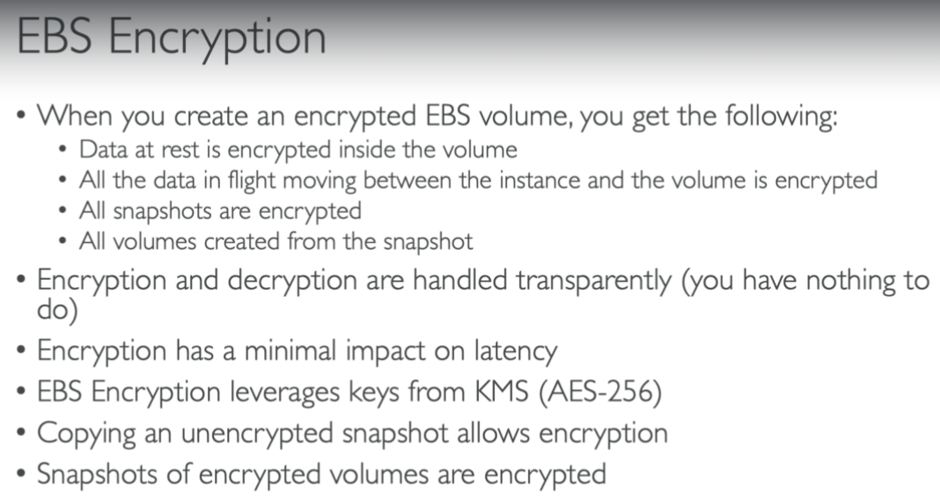

* Even if we create a volume from a non encrypted snapshot. Then that volume will also be non-encrypted by default

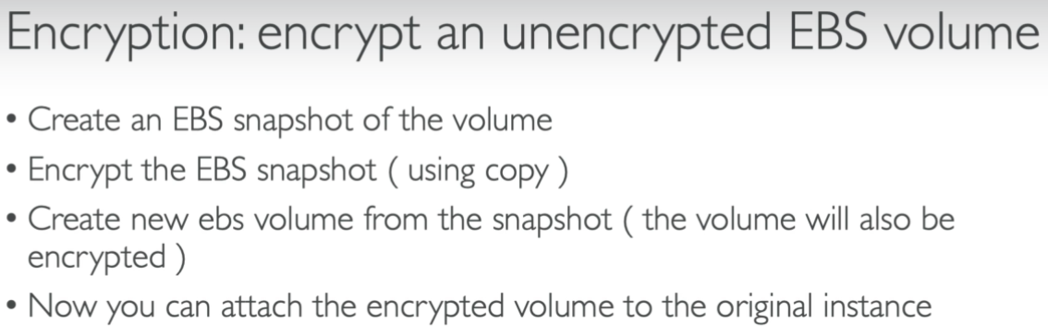

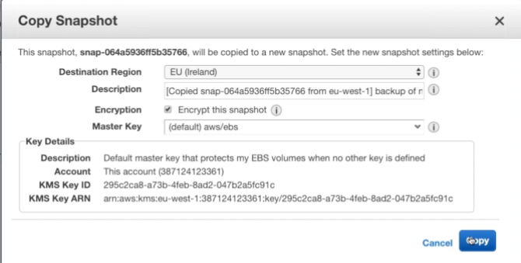

* We need to use the copy method as above and select the option to encrypt the snapshot.

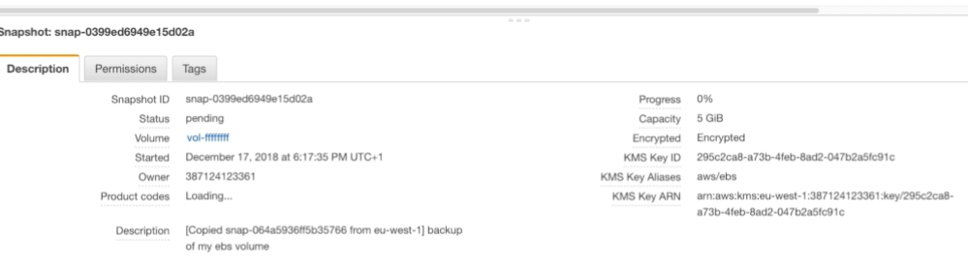

* We can see that encryption details as above.
* It shows that volume is encrypted and the KMS details as well.
* And now, we can create a volume out of it. So that the volume will also be encrypted because the snapshot was encrypted.